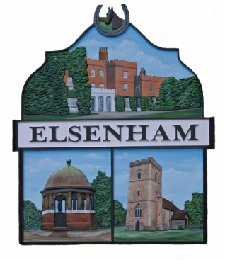

ANNUAL PARISH MEETING

AGENDA

NOTICE IS HEREBY GIVEN that the
ANNUAL PARISH MEETING
is to be held on
Thursday 28 April 2022, commencing at 8.00pm.
Members of the public are invited to attend.
An opportunity will be given for parishioners to speak during the open forum.

1. To receive and approve apologies for absence

2. To agree the minutes of meeting held on 22 April 2021

3. County Councillor’s Report

4. Parish Council Chairman’s Report

5. Parish Council Financial Report

6. District Councillors’ Report

8. Open Forum

9 Chairman’s Closing Remarks

