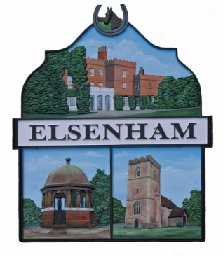
Elsenham Parish Council

Communication Committee Meeting via Zoom
held on Wednesday 7 April 2021 at 8pm

Minutes
(All meetings are open to the public and press)
Present:
Mrs. M Jackson (Chairperson MJ), Mrs. F Lambert (FL),
Mr. A Buonocore (AB), Mrs. A Gleeson (AG) Dr. G Mott (GM)
and Mrs. L Johnson (Parish Clerk LJ).

Members of the public: None.
Apologies for absence: None
Item | Actions agreed
Declarations of Interest: None.
Open to the Public: None present.
Minutes  The Committee agreed the minutes of the meeting held on 27 January 2021. | The minutes were agreed as a true and accurate record.
Matters arising from last meeting: None.
Budget for 2021/2022
The new financial year started on 1 April 2021, the Communication Committee budget for 2021/2022 is £750.
Social Media and Website Review
AB has made some changes to the document archive, adding categories for the various committees. All documents are now in their correct category. The next step will be to archive all the necessary historical documents.
All agendas are now programmed to expire a week after the meeting is due to be held.

AB said he would like to carry out some research, with the possibility of introducing it to the website, of the little chat box that appears in the corner of the screen. AB would program it with answers to common questions asked by residents.

The post that GM asked to be placed on social media regarding
North Hall Road had already been placed on there by Henham.
It was agreed to leave it one week and then re post it.

The Communication Committee feel that any item placed on social media should be generated by the committee. Things that work well on posters do not necessarily work well on social media.

MJ will be out of circulation for a couple of weeks, and may require help with the Social Media, AG offered to help.
AOB  Netwise has asked that any problems are put on their support ticket website. So, in future if all members use this system instead of emailing AG it should get any problems resolved quicker.  Once a member has put a ticket in, they can email other members to inform them.  GM asked that some publicity was given to the Gladman planning application, which was on the agenda for UDC’s Planning Committee meeting on 14 April 2021. MJ will place on Social Media and AB will add it to the website | AG to send link for the ticket site.
Next meeting 2 June 2021 at 8.00pm
Meeting closed at 8.25

