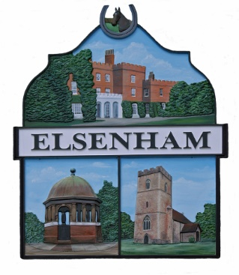
Elsenham Parish Council Planning Committee
Meeting with Bloor Homes
(Fairfield Development)
Land east of Elsenham, to the north of the B1051,
Henham Road, Elsenham

Up to 350 New Dwellings

To be held on Wednesday 21 July 2021
at 8.00pm via Zoom
Meeting ID: 830 2238 1185
Passcode: 242922
All meetings are open to the public and press.
AGENDA
- Apologies for absence.

- Declaration of Interests.

- Presentation by Bloor

- Draft layout (which we would expect you to provide);

- Community Hall, details sent.

- Housing mix and number of storeys.

- Parking provision.

- Public Open Space.
- Questions from councillors.

- Questions from members of the public.

