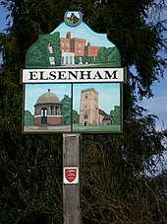

**22 April 2021**

**8pm**

## **Presentations from:**

## **County, District and Parish Council**

## **Special Presentation on proposed New Community Hall**

## **for Full details: ELSENHAM-PC.GOV.UK**

## **or** [**Louise.epc@gmail.com**](mailto:Louise.epc@gmail.com)

**Annual Parish Meeting**

# Elsenham Parish Council

# Virtual Meeting – held on ZOOM

✹

✹