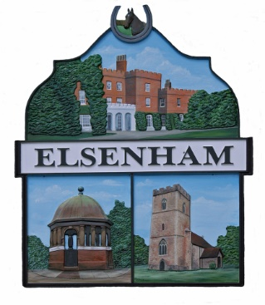

Elsenham and Ugley Parish Councils are holding a joint meeting with the developer Gladman.

All members of the public are welcome.

Please join us.
This is an opportunity to have your say

The meeting is to be held on Wednesday 9 December 2020
at 7.30pm via Zoom.
Meeting ID: 812 8159 6933
Passcode: 856717

Gladman have submitted plans for up to 220 dwellings
on land north of Bedwell Road.
This development will have an impact on Elsenham, with extra traffic and commuters, plus the demands on the
doctors’ surgery, the primary school and shops.

If you are new to Zoom and require some help to get started, please phone Moyra 01279 647351 who will be happy to help.

